**Table of content**

**1.READING THE DATA SET AND PREPROCESSING**

1. **VISUALIZTION OF DATA**
2. **NORMALIZING THE DATA AND PERFORM CLUSTERING**

Modeling Nepal Earthquake damage

The dataset mainly consists of information on the buildings' structure and their legal ownership. Each row in the dataset represents a specific building in the region that was hit by Gorkha earthquake.

There are 39 columns in this dataset, where the building column is a unique and random identifier. The remaining 38 features are described in the section below. Categorical variables have been obfuscated random lowercase ascii characters. The appearance of the same character in distinct columns does not imply the same original value.

Thata data set has been downloaded from <https://www.drivendata.org/competitions/57/nepal-earthquake/>

<https://www.kaggle.com/mullerismail/richters-predictor-modeling-earthquake-damage/activity>

1. **READING DATA SET AND DATA PREPROCESSING**

The data set has following attributes

* ***geo_level_1_id, geo_level_2_id, geo_level_3_id :*** geographic region in which building exists, from largest (level 1) to most specific sub-region (level 3). Possible values: level 1: 0-30, level 2: 0-1427, level 3: 0-12567.
* ***count_floors_pre_eq :*** number of floors in the building before the earthquake.
* ***age (type: int):*** age of the building in years.
* ***area_percentage :*** normalized area of the building footprint.
* ***height_percentage :*** normalized height of the building footprint.
* ***land_surface_condition :*** surface condition of the land where the building was built. Possible values: n, o, t.
* ***foundation_type :*** type of foundation used while building. Possible values: h, i, r, u, w.
* ***roof_type :*** type of roof used while building. Possible values: n, q, x.
* ***ground_floor_type :*** type of the ground floor. Possible values: f, m, v, x, z.
* ***other_floor_type :*** type of constructions used in higher than the ground floors (except of roof). Possible values: j, q, s, x.
* ***position :*** position of the building. Possible values: j, o, s, t.
* ***plan_configuration :*** building plan configuration. Possible values: a, c, d, f, m, n, o, q, s, u.
* ***has_superstructure_adobe_mud :*** flag variable that indicates if the superstructure was made of Adobe/Mud.
* ***has_superstructure_mud_mortar_stone):*** flag variable that indicates if the superstructure was made of Mud Mortar - Stone.
* ***has_superstructure_stone_flag :*** flag variable that indicates if the superstructure was made of Stone.
* ***has_superstructure_cement_mortar_stone (type: binary):*** flag variable that indicates if the superstructure was made of Cement Mortar - Stone.
* ***has_superstructure_mud_mortar_brick :*** flag variable that indicates if the superstructure was made of Mud Mortar - Brick.
* ***has_superstructure_cement_mortar_brick :*** flag variable that indicates if the superstructure was made of Cement Mortar - Brick.
* ***has_superstructure_timber***  indicates if the superstructure was made of Timber.
* ***has_superstructure_bamboo***  indicates if the superstructure was made of Bamboo.
* ***has_superstructure_rc_non_engineered*** indicates if the superstructure was made of non-engineered reinforced concrete.
* ***has_superstructure_rc_engineer*** if the superstructure was made of engineered reinforced concrete.
* ***has_superstructure_other*** if the superstructure was made of any other material.
* ***legal_ownership_status*** legal ownership status of the land where building was built. Possible values: a, r, v, w.
* ***count_families :*** number of families that live in the building.
* ***has_secondary_use***flag variable that indicates if the building was used for any secondary purpose.
* ***has_secondary_use_agriculture***  flag variable that indicates if the building was used for agricultural purposes.
* ***has_secondary_use_hotel :*** flag variable that indicates if the building was used as a hotel.
* ***has_secondary_use_rental :*** flag variable that indicates if the building was used for rental purposes.
* ***has_secondary_use_institution:*** flag variable that indicates if the building was used as a location of any institution.
* ***has_secondary_use_school :*** flag variable that indicates if the building was used as a school.
* ***has_secondary_use_industry ):*** flag variable that indicates if the building was used for industrial purposes.
* ***has_secondary_use_health_post :*** flag variable that indicates if the building was used as a health post.
* ***has_secondary_use_gov_office):*** flag variable that indicates if the building was used fas a government office.
* ***has_secondary_use_use_polic:*** flag variable that indicates if the building was used as a police station

After configuring the dataset In jupyter notebook and finding the dtypes we found that

<class 'pandas.core.frame.DataFrame'>

RangeIndex: 260601 entries, 0 to 260600

Data columns (total 39 columns):

# Column Non-Null Count Dtype

--- ------ -------------- -----

0 building_id 260601 non-null int64

1 geo_level_1_id 260601 non-null int64

2 geo_level_2_id 260601 non-null int64

3 geo_level_3_id 260601 non-null int64

4 count_floors_pre_eq 260601 non-null int64

5 age 260601 non-null int64

6 area_percentage 260601 non-null int64

7 height_percentage 260601 non-null int64

8 land_surface_condition 260601 non-null object

9 foundation_type 260601 non-null object

10 roof_type 260601 non-null object

11 ground_floor_type 260601 non-null object

12 other_floor_type 260601 non-null object

13 position 260601 non-null object

14 plan_configuration 260601 non-null object

15 has_superstructure_adobe_mud 260601 non-null int64

16 has_superstructure_mud_mortar_stone 260601 non-null int64

17 has_superstructure_stone_flag 260601 non-null int64

18 has_superstructure_cement_mortar_stone 260601 non-null int64

19 has_superstructure_mud_mortar_brick 260601 non-null int64

20 has_superstructure_cement_mortar_brick 260601 non-null int64

21 has_superstructure_timber 260601 non-null int64

22 has_superstructure_bamboo 260601 non-null int64

23 has_superstructure_rc_non_engineered 260601 non-null int64

24 has_superstructure_rc_engineered 260601 non-null int64

25 has_superstructure_other 260601 non-null int64

26 legal_ownership_status 260601 non-null object

27 count_families 260601 non-null int64

28 has_secondary_use 260601 non-null int64

29 has_secondary_use_agriculture 260601 non-null int64

30 has_secondary_use_hotel 260601 non-null int64

31 has_secondary_use_rental 260601 non-null int64

32 has_secondary_use_institution 260601 non-null int64

33 has_secondary_use_school 260601 non-null int64

34 has_secondary_use_industry 260601 non-null int64

35 has_secondary_use_health_post 260601 non-null int64

36 has_secondary_use_gov_office 260601 non-null int64

37 has_secondary_use_use_police 260601 non-null int64

38 has_secondary_use_other

We omitted the building id since its just the number indicating the buildings. WE the converted all the object files into the integer file. There were no missing values in this data set

1. VISUALIZING THE DATA SET

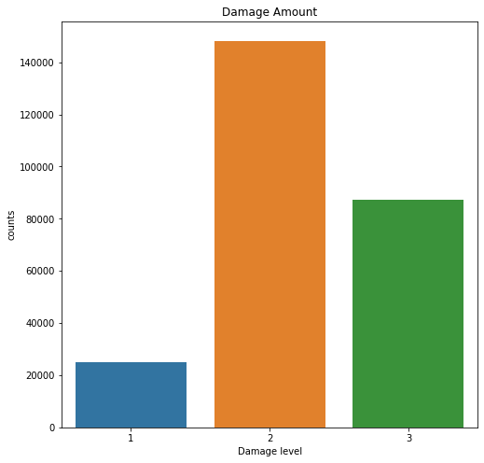

This is amount of buildings categorized by the damage level 1, little damage, 2, Sufficient damage and 3 as a heavy damage

And below is the percentage of the damage grade

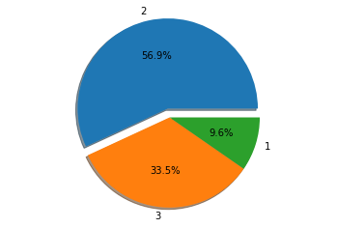

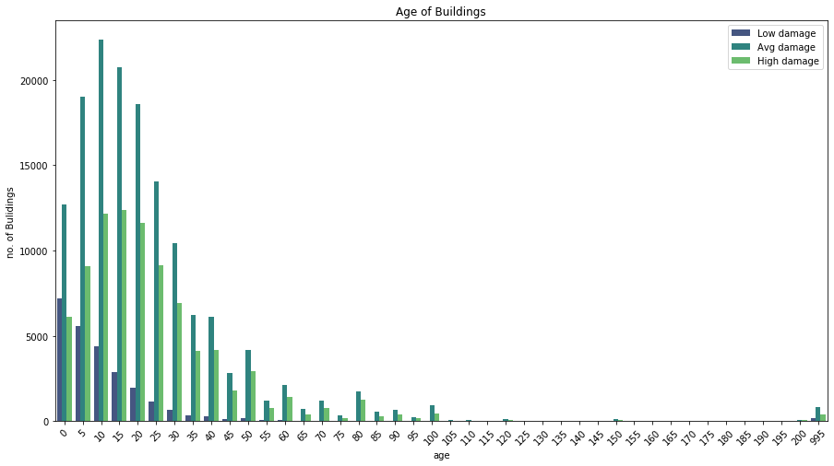

The above graph indicates the age of the building in the Nepal, where most of the data has been from the age group 0-50 age and there are also very few building which are more than 200 year old( old temples and monuments)

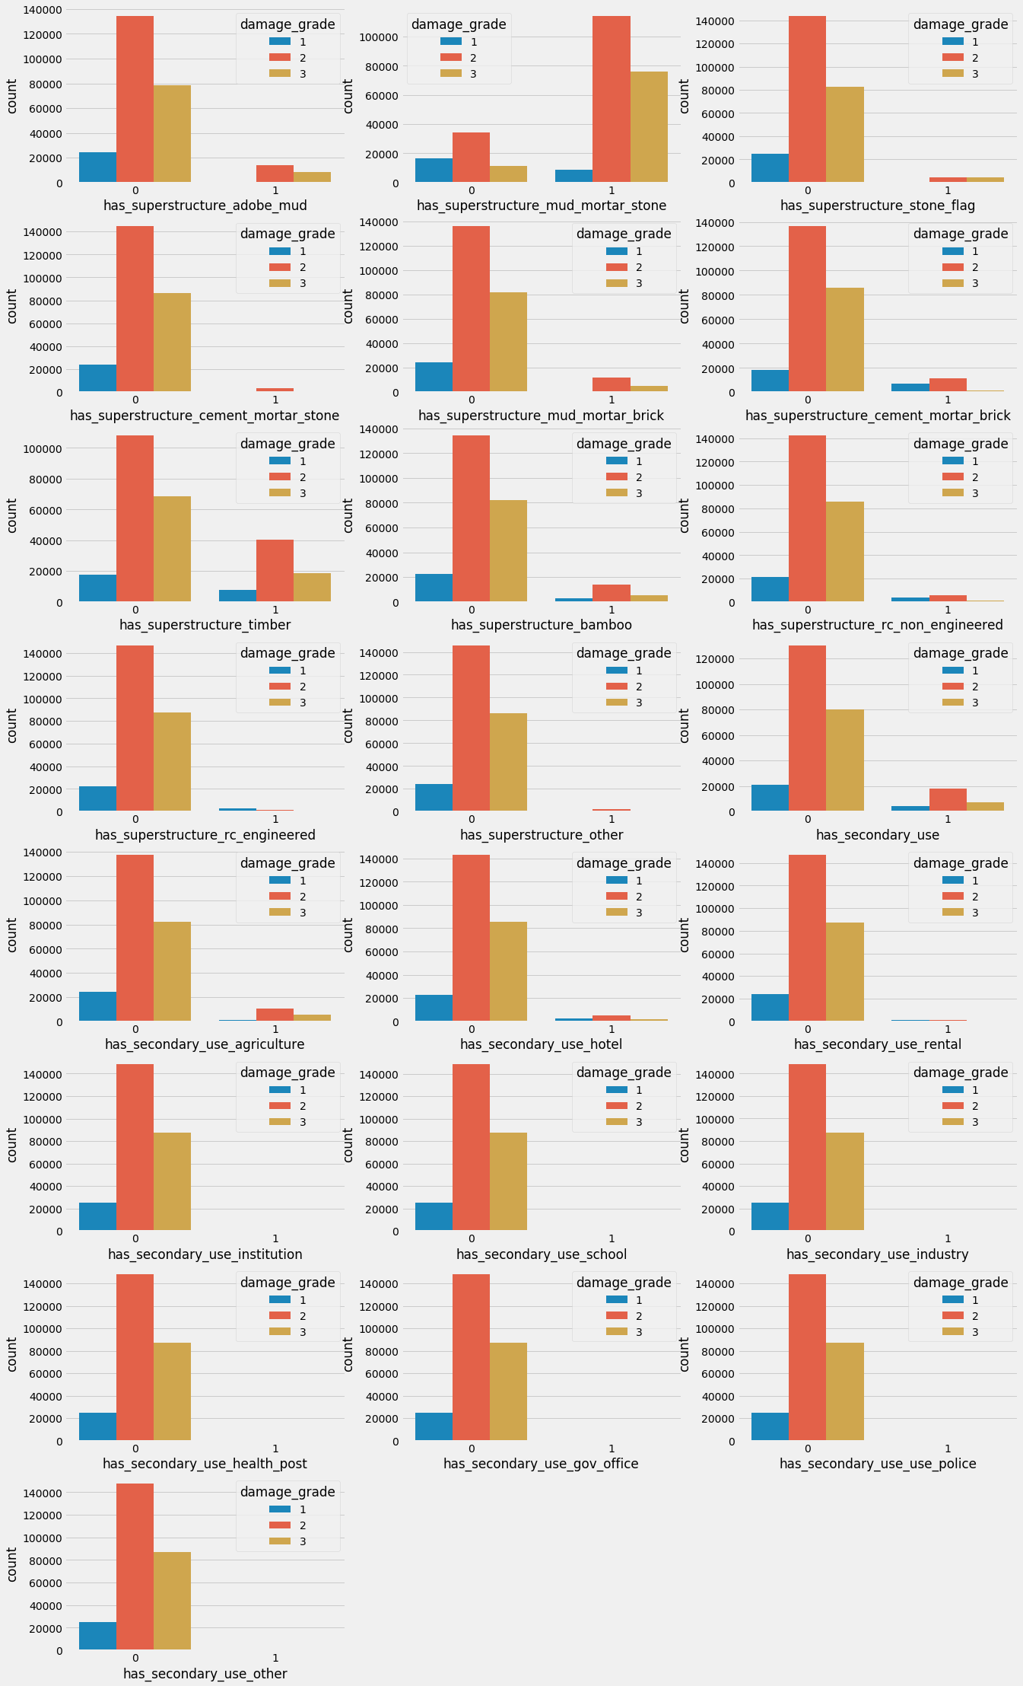

The level of damage grade according to the structure of the house.

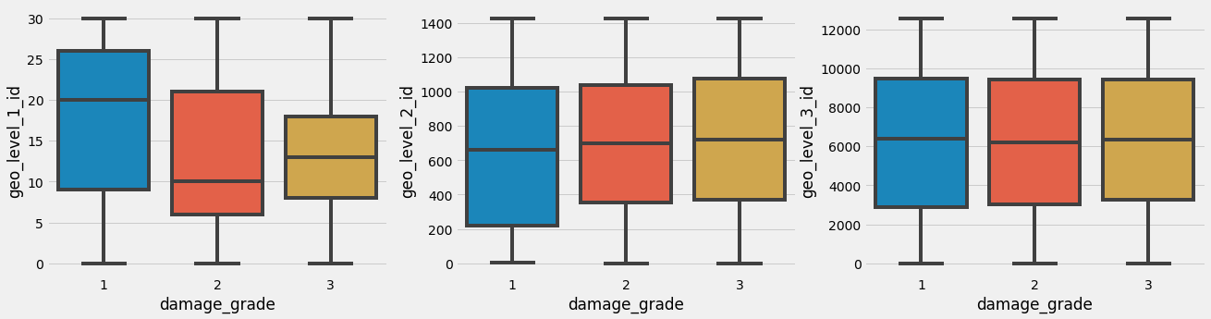

The above graph indicates the box plot of the damage grade with respect to the geo level id 1 , 2 and 3

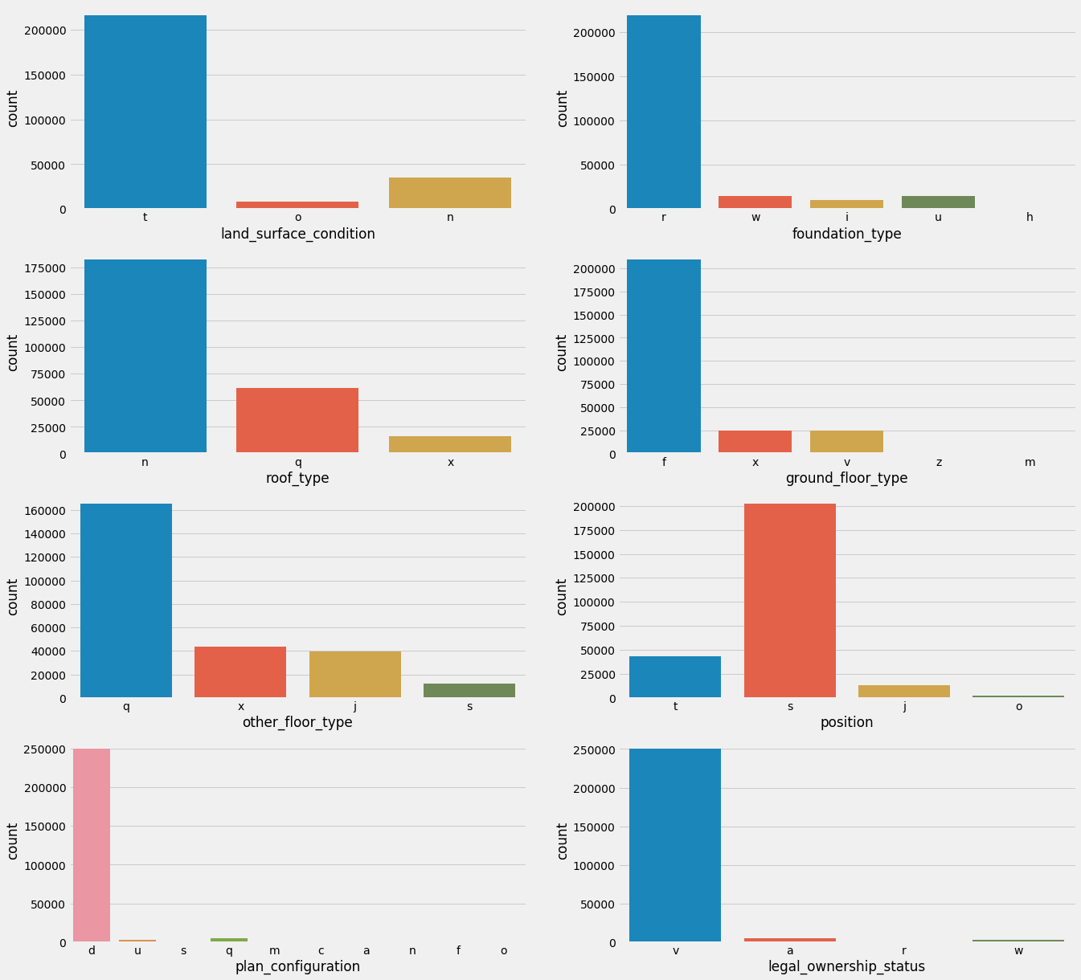

The following graph indicates damage grade according to the surface conditions,

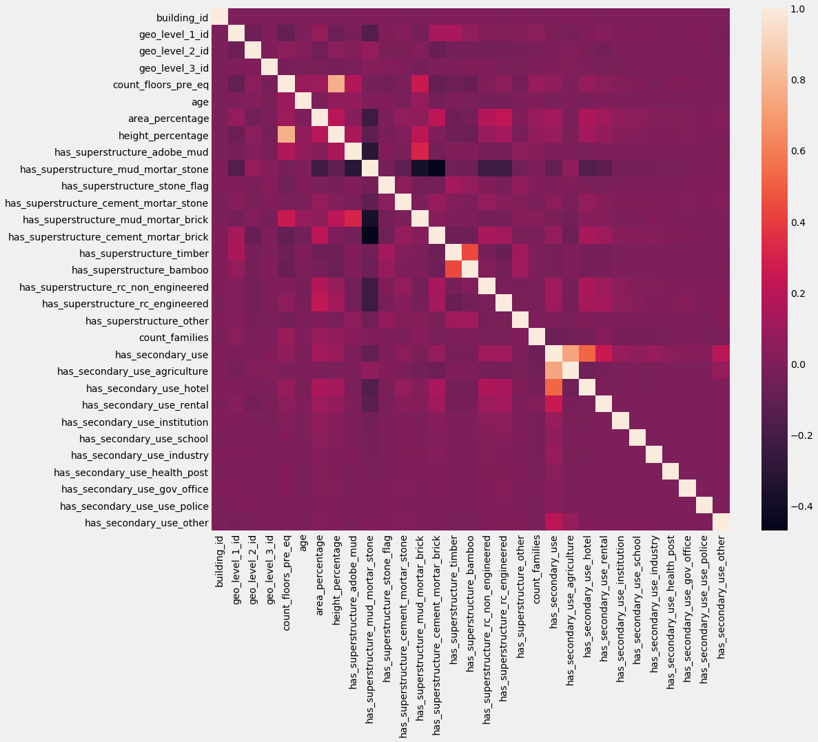

HEAT MAP OF ALL CONDITIONS

3.NORMALIZING THE DATA AND PERFORM CLUSTERING

There are two methods of clustering that i implemented in the project , one is the normal traditional method and another with sklearn library. After performing the clustering thorugh the mean of K mean sklearn library we obtain the following graphs

Choosing number of cluster as 2

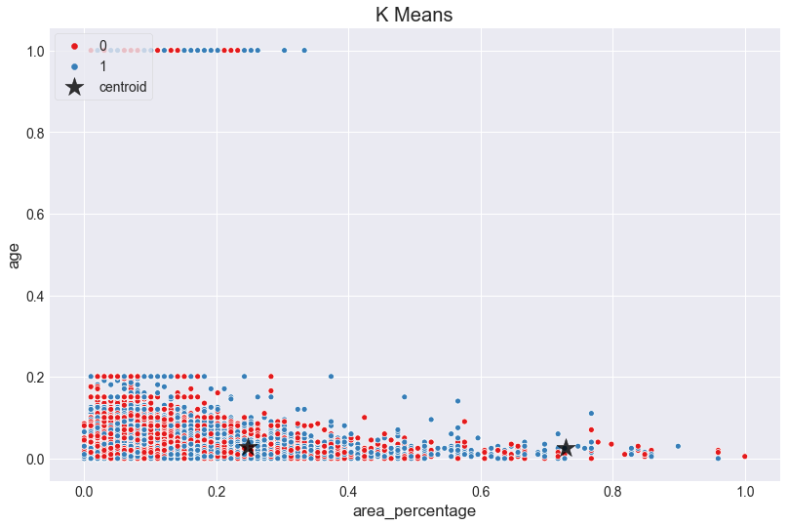

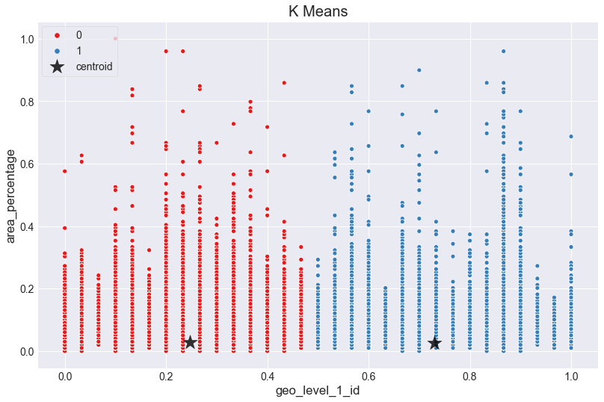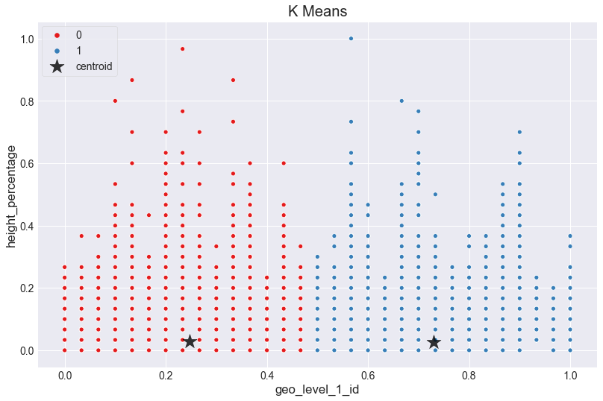

Using number of cluster as 3

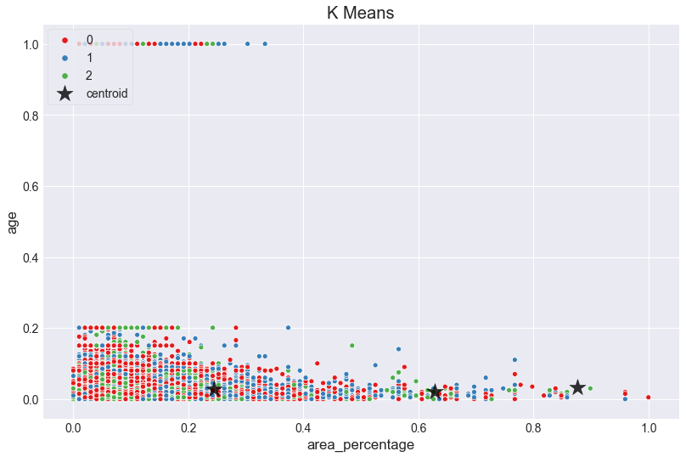

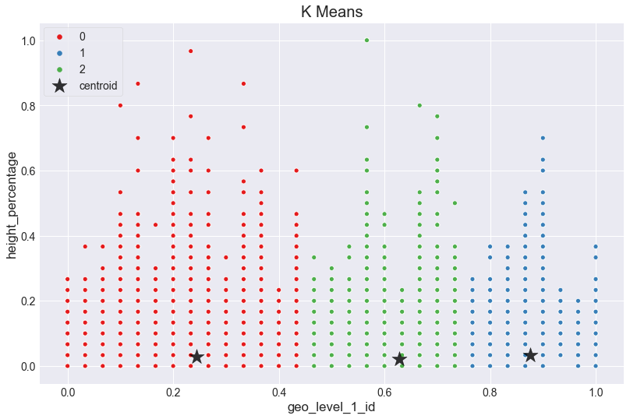

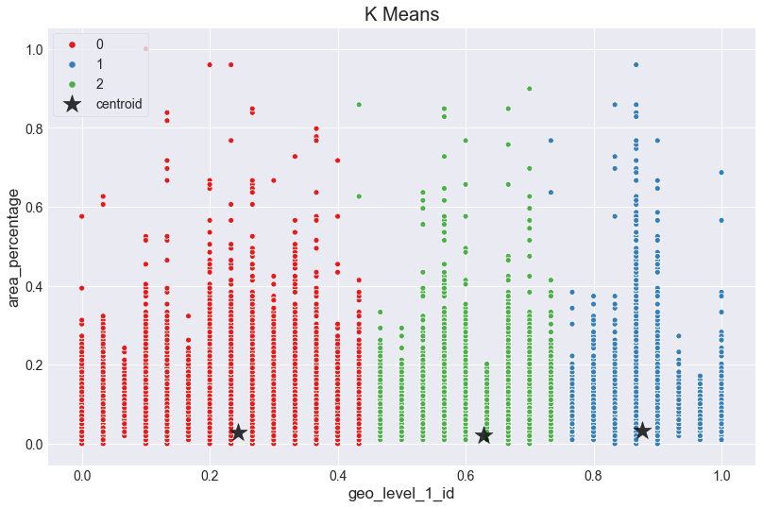

Using number of clusters as 5

